**BIOSCI 395 - Southern Conifers Assignment**

For this simplified dataset of biogeography data for southern conifers (Podocarpaceae and Araucariaceae) from Klaus & Matzke (2020), the dispersal model with the best fit is DEC*j*+*x*+*m*, which has an AICc model weight of 99.92% (Table 1). There were no competitive models; the only other model that had an AICc model weight above 0.00% was DEC*j*+*x* (0.08%). Both of these models include parameters for founder-event jump dispersal and distance on the rate of dispersal for southern conifers. Comparing the dispersal (range expansion) and extinction (range contraction) parameters, it is evident that southern conifers have shown a trend for range expansion in every model (*d* > *e*).

Our model-comparison analyses indicate that models where dispersal is dependent on trait (seed cone fleshiness), geographical distance and jump dispersal were better fits to the data compared to models in which dispersal was independent of these factors. For the trait-dependent dispersal multiplier m2, the estimated value of 0.995 in the best-fitting model suggests that dispersal rates are 0.5% lower for lineages with non-fleshy cones. However, every model revealed higher rates of transition from fleshy to non-fleshy cones (*t12*) than the reverse (*t21*), indicating an evolutionary trend towards non-fleshiness. Meanwhile, the geography parameter *x* reveals a strong negative correlation between distance and dispersal; the estimated value of -1.028 suggests that dispersal probability is halved when distance is doubled. Models with jump dispersal are also outperforming models without; there is support for jump dispersal having a meaningful effect (*j* = 0.559).

From these findings, we can conclude that the probability of dispersal for southern conifers is higher with fleshier cones and decreases with greater distances, and its biogeographic history is also dependent on founder-event jump dispersal. While there is limited support for the role of the cone-fleshiness trait in increasing the probability of long-distance dispersal, it is still a meaningful effect. This likely evolved alongside bird dispersal, allowing seeds to be carried across great distances to allow for jump dispersal as a mechanism for range expansion. This supports the historical biogeography findings in Figure 1 (Klaus & Matzke, 2020, p. 65) - that these basal lineages originated in Oceania (Australia, New Zealand and New Caledonia) then diverged towards Central and South America. Overall, it is clear that the biogeographical history of southern conifers is not independent of trait, distance or jump dispersal.

**Table 1.** AIC values with likelihood and parameter estimates for a range of trait and geography models on dispersal in southern conifers

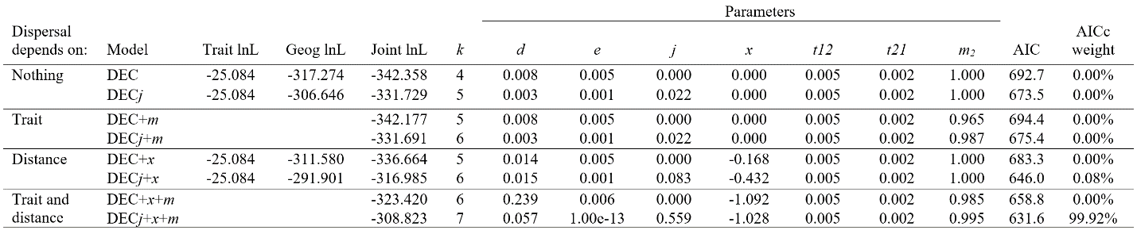

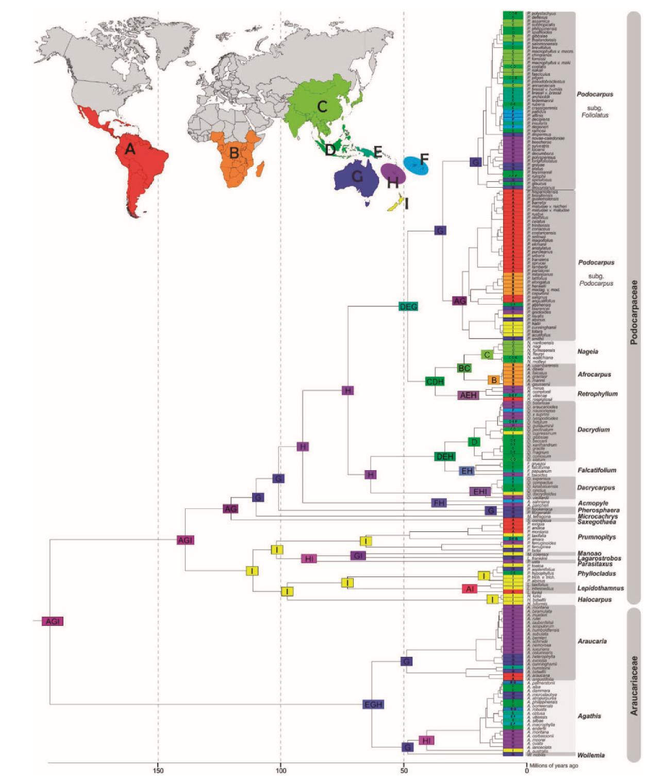

**Figure 1.** World distribution map and phylogeny illustrating the trait-dependent historical biogeography of Podocarpaceae and Araucariacea. Reprinted from “Statistical Comparison of Trait-Dependent Biogeographical Models Indicates That Podocarpaceae Dispersal Is Influenced by Both Seed Cone Traits and Geographical Distance,” by K.V. Klaus and N. J. Matzke, 2020. *Systematic Biology, 69*(1), p. 65. Copyright 2019 by The Authors.

**References**

Klaus, K. V., & Matzke, N. J. (2020). Statistical comparison of trait-dependent biogeographical models indicates that Podocarpaceae dispersal is influenced by both seed cone traits and geographical distance. Systematic Biology, 69(1), 61-75. <https://doi.org/10.1093/sysbio/syz034>